RE-EVALUATION OF THE USE OF LOW ACTIVATION MATERIALS IN WASTE MANAGEMENT STRATEGIES FOR FUSION∗

David A. Petti and Kathryn A. McCarthy
Fusion Safety Program
Idaho National Engineering and Environmental Laboratory
Neill P. Taylor, Cleve B.A. Forty and
Robin A. Forrest
Euratom/UKAEA Fusion Association
Culham Science Centre

ABSTRACT

The world fusion programs have long had as a goal that fusion power stations should produce only low level waste and thus not pose a burden to future generations. However, the environmental impact of waste material is determined not only by the level of activation, but also the total volume of activated material. Because a tokamak power plant is large, the potential exists to generate a correspondingly large volume of activated material. The adoption of low activation materials, while important to reduce the radiotoxicity of the most active components, should be done as part of a strategy that also minimizes the volume of waste material that might be categorized as radioactive, even if low level. In this paper we examine different fusion blanket and shield designs in terms of their ability to limit the activation of the large vessel/ex-vessel components (e.g. vacuum vessel, magnets) and we identify the trends that allow improved in-vessel shielding to result in reduced vessel/ex-vessel activation. Recycling and clearance are options for reducing the volume of radioactive waste in a fusion power plant. Thus, the performance of typical fusion power plant designs with respect to recycling and clearance criteria are also assessed, to show the potential for improvement in waste volume reduction by careful selection of materials combinations. We discuss the impact of these results on fusion waste strategies and on the development of fusion power in the future.

INTRODUCTION

Materials choice has long been recognized as a key factor in realizing the full safety and environmental potential of fusion power. Because the materials are de-coupled from the fusion energy source (the plasma), the long-term neutron-induced activation of components can be tailored by proper selection of materials to avoid generation of waste that would require deep geological disposal. Thus, the idea of “low activation” materials was conceived for the fusion program with the hope that such material could be disposed of as low level waste (e.g., cleared or shallow land burial) and would not pose a burden to future generations.

The environmental impact of waste material is, however, determined not only by the level of activation, but also the total volume of active material. A tokamak power plant is large, and there is a potential to generate a correspondingly large volume of activated material. The adoption of low activation materials, while important to reduce the radiotoxicity of the most active components, should be done as part of a strategy that also minimizes the volume of waste material that might be categorized as radioactive, even if low level. Waste management strategies have typically concentrated on minimizing the activity of first wall and blanket components where the level of specific activity (Bq/kg) is highest [].

Some materials may become candidates for recycling, and others may be cleared from regulatory control by meeting prescribed criteria that have yet to be agreed upon internationally. Recently these concepts of recycling or clearance have been recognized as options for reducing the volume of radioactive waste from a fusion power plant. Determining if a material can be recycled or cleared from regulatory control depends largely on our ability to limit the induced activation of the component. Thus, there is a need to re-optimize the blanket and shield of conceptual fusion designs to achieve an optimal balance of the parameters which influence neutronic behavior and thereby substantially reduce the activation of the large ex-vessel components that contribute significantly to the overall volume of activated material. The impact of these parameters on other aspects of plant performance must also be considered.

This paper reports on scoping studies with neutronics and activation models to examine these issues, and identifies the trends that allow improved in-vessel shielding to result in reduced vessel/ex-vessel activation. The performance of representative fusion power plant designs with respect to recycling and clearance criteria are also assessed, to show the potential for improvement in waste volume reduction by careful selection of materials combinations. The implications of the results on the development path for fusion power are discussed.

APPROACH, DESIGNS, AND METRICS

The approach taken here is to examine a broad range of blanket design concepts in Europe and the US with fixed plasma and ex-vessel components and determine their ability to minimize ex-vessel activation. Most of these blanket options are based on the tokamak power plant designs studied in the European Safety and Environmental Assessments of Fusion Power (SEAFP) [], in particular the three models adopted in the second phase of that study []. These were augmented by a lithium metal/vanadium concept based on work in the US at ANL [] and a silicon carbide variant of one of the SEAFP blankets. In all models the vacuum vessel and the magnets are invariant, and are identical with the original SEAFP plant design.

The five different design options are:
- Lithium oxide ceramic breeder/vanadium alloy structure/helium coolant
- Liquid LiPb breeder/low activation martensitic (LAM) steel structure/water coolant
- Lithium silicate ceramic breeder/ LAM steel structure/helium coolant
- Lithium silicate ceramic breeder/silicon carbide composite structure/helium coolant
- Self-cooled lithium breeder/vanadium alloy structure
In all cases except the lithium/V design, a water-cooled austenitic steel (containing a full set of elements and impurities) is used for the shield and vacuum vessel. For the lithium/V design, because of the safety concern related to lithium/water interaction, the shield and vacuum vessel are helium-cooled austenitic steel. Beyond the vacuum vessel is the superconducting magnet winding pack with the associated insulation enclosed in its austenitic steel coil case. A summary of the radial build of each design and the geometrical configuration of the machine is found in Table 1. Details are found in References [] and [].

All of the scoping calculation results reported here are for the outboard portion of the machine, where the largest volume of the components reside. To further explore the effect of changing the first wall/blanket structural material alone, one of these five design options, Design 3 in Table 1, was used as a baseline for further scoping study. In this case, all plant parameters were fixed except for the choice of first wall/blanket structural material. Four alternatives were considered: 316 stainless steel, low activation martensitic (LAM) steel, a vanadium alloy (V-4Cr-4Ti), and silicon carbide composite (SiC/SiC). They were chosen to span the range of activation properties of candidate structural materials.

The metrics used to measure the ex-vessel activation include:
- Total activity as an indication of where the induced activation is largest
- Shielding effectiveness of the blanket, as measured by the magnitude and spectral energy distribution of the neutron current leaving the blanket and leaving the shield
- Contact dose rate as a measure of the ability for either hands-on (10 µSv/hr) or remote (10 mSv/hr) recycling of the material [], and
- A clearance index based on IAEA recommendations [] regarding levels of activation below which a material is no longer classified as radioactive waste.

NEUTRONICS AND ACTIVATION MODELING

Computation of neutron flux spectra, nuclide inventories and related quantities are based on one-dimensional models of the radial build at the axial mid-plane of the tokamak. The radial co-ordinate is centered on the torus axis, and successive radial zones represent each major inboard and outboard component, out as far as the toroidal field coils. Within each zone a homogeneous mixture of the component materials was assumed in computing neutron transport and activation cross sections. For flux calculations, each zone was sub-divided into many smaller meshes.

The use of a simple one-dimensional model allows a range of concepts to be rapidly compared on a common basis, and allows the underlying features of the activation behavior to be examined. It does, however, neglect the important contribution to material activation by neutrons streaming down penetrations through the zones represented in the model. For example, ports for maintenance access and for neutral beams provide potential paths for enhanced neutron fluxes in the ex-vessel structure around the port, leading to increased activation. Two or three-dimensional models are needed to study the adequate shielding of these penetrations, which is beyond the scope of this paper. Here we are concerned only with how the bulk activation of materials is influenced by the materials in the in-vessel components, and therefore, the one-dimensional model is ideal for assessing this effect.

Neutron fluxes were computed in 175 energy groups using the discrete-ordinates code ANISN [] with neutron cross section data from the FENDL/E-2 library []. A P₃ S₈ approximation was used in infinite cylindrical geometry. Activation analyses were performed using the EASY-99 system comprising the FISPACT-99 neutron activation code [] and the most up-to-date European Activation File database, EAF-99 []. In addition to data on cross-sections, nuclear decay, hazards, stopping powers etc., the new libraries now also incorporate IAEA clearance indices [Error: Reference source not found], which we make use of in this analysis.

For the comparisons made in this paper, the calculated neutron flux spectra were volume-averaged in each of 17 outboard zones of the five plant models, and used to obtain the activation characteristics at a series of times after shut-down. All first wall and blanket zones were assumed to be exposed to fusion neutrons for 5 full power years, while all other zones were exposed for 25 years. A number of activation characteristics are obtained from the FISPACT calculations, including specific activity, total activity, contact gamma dose rate, and clearance index.

RESULTS AND DISCUSSION

Activation

Activation results are presented in a graphical format showing a variety of activation metrics as a function of radial location at 50 years following shutdown, this being judged to be an important time-scale for the consideration of waste management options. The first of these, Figure 1, shows the clearance index for each plant model. Other activation properties show similar behavior.

Moving radially outwards through the components of each plant model, there is the expected decline in the activation, and hence clearance index, as the neutron flux is attenuated. The step increase in activation at the backplate (where present) is attributed to this component having a plant lifetime of 25 years rather than 5 years (as for first wall and blanket). The in-vessel shield can be seen to reduce the activation by typically 4 orders of magnitude over its ~ 0.75-m thickness. A further decrease in activation response is seen at the vacuum vessel, and then at the magnets including their thick steel casing.

In comparing the activation response of the different plant models in Figure 1, a striking characteristic is immediately apparent. It is clear that optimizing the breeder, structure and coolant materials within the first wall and blanket to reduce the activation response in these regions, results in a higher activation in the shield, vacuum vessel and magnets. The converse is also true, as seen by comparing the behavior of ceramic/SiC/He with that of LiPb/LAM/water. Further, the level of induced activation of the vacuum vessel as given by the clearance index varies by a factor of 500 among the different design options. While the outboard magnets can be cleared in all cases, only in the LiPb/LAM/water design does the vacuum vessel meet the IAEA clearance limits. Much more could be cleared if the 316 stainless steel was replaced by a reduced-activation austenitic steel (e.g. OPSTAB) for all ex-blanket components, and the time was extended by a few decades.

There are a number of factors that contribute to the differences in the shielding effectiveness and induced activation among the design options, including:

- Choice of low activation structural material in first wall and blanket;
- Neutron moderating effectiveness of blanket coolant fluid;
- The presence/absence of beryllium or lead neutron multiplier;
- The degree of ⁶Li enrichment in lithium, if any;
- The thickness and composition of the shield.

In order to focus further on the first of these factors, Figure 2 shows results of the comparison of four first wall/blanket structural materials in the same plant model. As a representative example, this plot shows the contact gamma dose rate after 50 years. Key threshold limits shown in the figure indicate the levels at which hands-on access to the material, and recycling operations by remote handling, should be possible.

Because the plant geometry, tritium breeding material, coolant and all components outside the backplate are invariant, only the first wall/blanket structural material is responsible for the observed differences. It is again clear that the advantage of using SiC/SiC in the near-plasma zones (where it results in the lowest dose) is offset by a higher dose rate in the shield and many of the ex-vessel components (in most of which it yields the highest dose). By using 316 austenitic steel as a structure, the opposite features are broadly seen, that is high dose rates in the near-plasma components and lower dose rates in shield and ex-vessel components.

The use of total activity (Bq), rather than specific activity (Bq/kg), accounts for the greater volume and mass of the ex-vessel components and gives emphasis to the importance of minimizing activation in these zones. Thus, Figure 3 shows the total activity (Bq) for the fixed design (ceramic/He) with the four alternative structural materials. With the exception of SS316, which shows the highest total activity in the near-plasma components, the highest total activity in all variants is in the shield region. It is particularly notable that the SiC/SiC-based case, which might have been expected to be the lowest activation, is some 5 times higher in total activation than the other options, and this difference is maintained out through the winding pack region of the magnets. Conversely, the 316 stainless steel, which gives much higher activity in the blanket and the highest overall total activation, is nevertheless the lowest in this shield region.

Neutron Spectral Effects

The underlying causes of the differences in the various activation results can be understood more fully by examining the neutron spectra at various locations in the radial builds of the different design options. Figures 4 through 6 are selected spectra, plotted as group flux values per unit logarithmic energy decrement (lethargy) of group width.

The neutron spectra in the five plant models at the back of the shield just inside the vacuum vessel are plotted in Figure 4. The flux exiting the shield varies in magnitude by about a factor of 500 across the five design options. It is evident that the four models employing steel/water shields have very similar spectral shapes at this point. The Li/V/Li model has very much lower flux at the high energies, probably due to inelastic scattering in ⁷Li within the blanket (the lithium is not enriched). However the absence of water from the shield of this design (helium-cooled steel) reduces overall moderation and permits a higher penetration by intermediate-energy neutrons. These neutrons do become effectively moderated outside the vacuum vessel in other water-cooled components, but not before they have contributed substantial activation in the shield and vessel.

Furthermore, these differences in neutron flux translate directly into the factor of 500 spread in clearance indices for the vacuum vessel of the different design options shown in Figure 1. The neutron flux leaving the outboard shield must be reduced by a factor of 100 to 250 to allow the outboard vacuum vessel of the other design options to be cleared. Of course, in a design driven by the need to reduce ex-vessel activation, the neutron flux exiting the shield could be adjusted by changing the shield thickness. However there is a clear economic penalty of increasing shielding thickness, particularly as this drives the radial dimensions of all outer plant components. Increasing the outboard shield thickness to accommodate such a large reduction in neutron flux may not be feasible. As indicated earlier, using 18 cm of stainless steel/water gives an order of magnitude reduction in neutron flux. Thus, an additional 20 to 50 cm of shield thickness would be needed to reduce the neutron flux to the levels required to allow clearance of the vacuum vessel in the other design options. Furthermore, increasing the shield thickness will not reduce the activation of the shield itself, which, as Figure 3 has shown, is where the greatest total activity lies.

It is therefore important to look at the differences of neutron transmission through the blankets of the different models. This is done in Figure 5, which shows the neutron flux spectra exiting the blanket. Significant differences in the flux spectra are evident, although the flux levels are not as widely spread as at the back of the shield (Figure 4). This indicates the importance of moderating the neutron flux as early as possible, on which measure the LiPb/LAM/water concept performs very well. The ordering of the flux levels in the shield is roughly the same as the flux above 1 MeV in this plot, with the exception of the anomalous Li₂O/V/He result. (The oxide/V/He option has a very hard spectrum due to the low lithium atomic density and absence of other moderating material in this blanket concept.)

It is interesting once again to separate out the effect of the structural material alone, by observing in Figure 6 the spectra of neutrons exiting the blanket in each of the models with different first wall/blanket structure but otherwise invariant design. Although the spectral differences are less pronounced, they are important enough to result in the significant activation differences observed in Figure 2.

SUMMARY, RECOMMENDATIONS AND FUTURE WORK

The use of different low activation material/coolant combinations in the blanket produces very different levels of activation in the shield, vacuum vessel and magnets. While low activation materials do reduce the long-term activation hazard of the waste, their use in and of itself does not necessarily reduce the volume of activated material and the subsequent amount of radioactive waste arising from the plant. As has been shown previously, [,,,] the development of low activation materials to reduce the in-vessel radiotoxicity hazard requires careful attention to impurities in the materials used in the near plasma components. But while impurities are still important, the reduction of vessel/ex-vessel activation to levels that would allow the vacuum vessel and magnets to be cleared also requires improved bulk shielding by the blanket and shield, or the use of reduced-activation austenitic steel together with a longer decay time before disposal.

The combination of water, LiPb and low activation martensitic steel in the blanket provides superior shielding of all the blankets considered from an ex-vessel neutron activation standpoint. The shielding offered by the Pb and the moderation of the water results in the lowest specific activity, dose rate and clearance index in the shield and vacuum vessel of all the designs considered. Vessel/ex-vessel activation is primarily a function of the choice of low activation structural material in first wall and blanket and the neutron moderating effectiveness of blanket coolant fluid, as well as the choice of materials for the ex-vessel components themselves. These factors directly influence the overall ex-vessel activation and the ability to clear ex-vessel components and furthermore indicate that a single material/design for the shield is not optimal for all blankets. The differences in the neutron spectra produced by different material combinations must be considered when neutronically optimizing a shield to reduce the overall activation of the bulky ex-vessel components in the plant. Simply increasing the shield thickness does not appear to be a feasible means of reducing ex-vessel activation so that the vacuum vessel and magnets can be cleared. The neutron flux should be moderated as close to the plasma as possible.

A waste management strategy focused solely on low activation materials does not address the entirety of the radioactive waste picture for fusion. We recommend a strategy that is balanced with respect to minimizing both the hazard (via low activation materials) and the volume (via reduction of ex-vessel activation). As such we propose the following minimum design goals:
- To reduce the overall radioactive waste volume by limiting vessel/ex-vessel activation so that the outboard vacuum vessel and all magnet components be cleared using IAEA clearance rules or recycled for re-use.
- To ensure that all activated material in a fusion plant that cannot be cleared or recycled be disposed of as low level waste and thus not pose a burden to future generations.
Furthermore, there is also a need to better understand the tradeoffs associated with this dual strategy of minimizing both hazard and volume. For example, our results here suggest that some choices of low activation materials for near plasma components suffer the penalty of enhanced neutron penetration, giving rise to higher overall levels of activation, contact dose rate, and clearance index in the shield and ex-vessel components. Materials are considered "low activation" either because their neutron cross sections are low or because their activation products are stable or benign (short-lived), or some combination of these two properties. Those which are merely low absorption may result in higher overall plant activated material volume. Systems and power plant studies should examine in a systematic manner the tradeoffs associated with changing blanket and shield materials to meet these new design goals relative to changes in the radial build of the machine, cost of energy, performance impacts and reduction of radioactive waste volume.

Table 1. Radial Build and Geometric Configuration used in the analysis
 | Outer Radius (m) | Design 1 | Design 2 | Design 3 | Design 4 |  | Design 5
IB TF coils | 4.05 - 5.60 | Coil case, insulator and winding pack
IB Vacuum Vessel | 5.67 - 6.02 | Steel, water, boron carbide and lead. |  |  |  | 90% steel, 10% helium
IB Shield | 6.04 - 6.95 | 80% steel 20% water |  |  |  |  | 90% steel, 10% helium
IB Blanket | 6.04 - 6.95 | V alloy, Li₂O, helium | LAM* steel, LiPb, water | LAM* steel, Li₄SiO₄, Be, helium | SiC, Li₄SiO₄, Be, helium |  | Li, V alloy, Be, TiC
IB First Wall | 6.04 - 6.95 | Be, V alloy, helium | Be, LAM* steel, water | Be, LAM* steel, helium | Be, SiC, helium |  | Li, V alloy,
Plasma | 11.7
OB First Wall | 11.7 - 13.25 | Be, V alloy, helium | Be, LAM* steel, water | Be, LAM* steel, helium | Be, SiC, helium |  | Li, V alloy,
OB Blanket | 11.7 - 13.25 | V alloy, Li₂O, helium | LAM* steel, LiPb, water | LAM* steel, Li₄SiO₄, Be, helium | SiC, Li₄SiO₄, Be, helium |  | Li, V alloy, Be, TiC
OB Shield | 11.7 - 13.25 | 80% steel 20% water |  |  |  |  | 90% steel, 10% helium
OB Vacuum Vessel | 13.27 - 13.7 | Steel and water |  |  |  | 90% steel, 10% helium
OB TF Coils | 13.8 - 15.53 | Coil case, insulator and winding pack
* Low activation martensitic
Figure Captions

Figure 1. Clearance index for different design options

Figure 2. Contact dose rate after 50 years for different design options

Figure 3. Total activity (Bq) for different design options

Figure 4. Neutron flux exiting the shield for the various design options

Figure 5. Neutron flux exiting the blanket for the different design options

Figure 6. Effect of structural material on the neutron flux exiting the blanket for the helium cooled ceramic design option
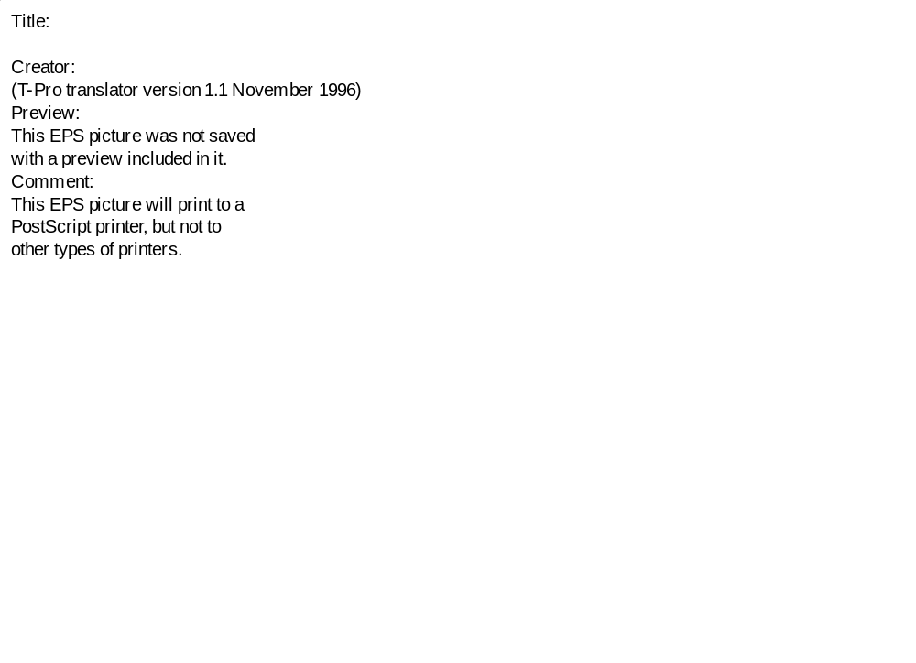

Figure 1
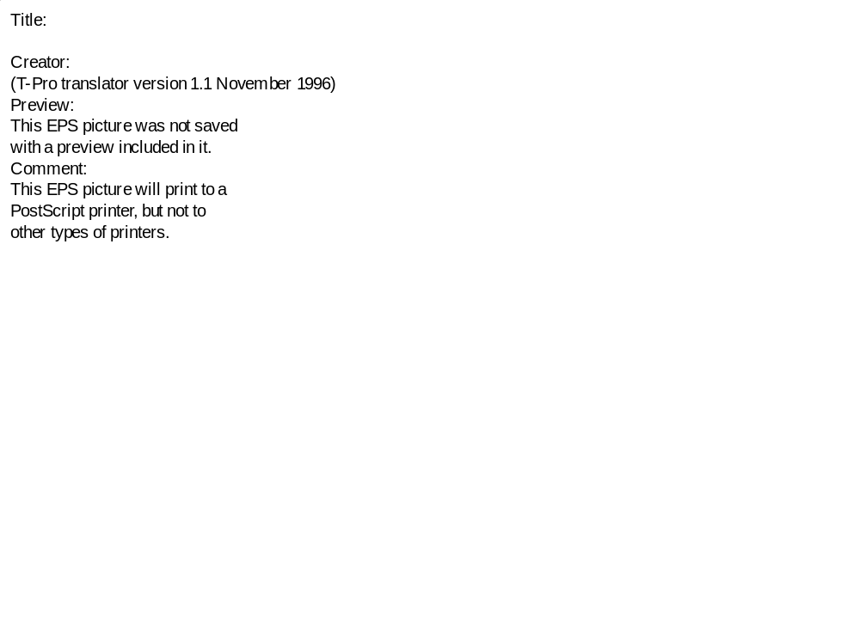

Figure 2
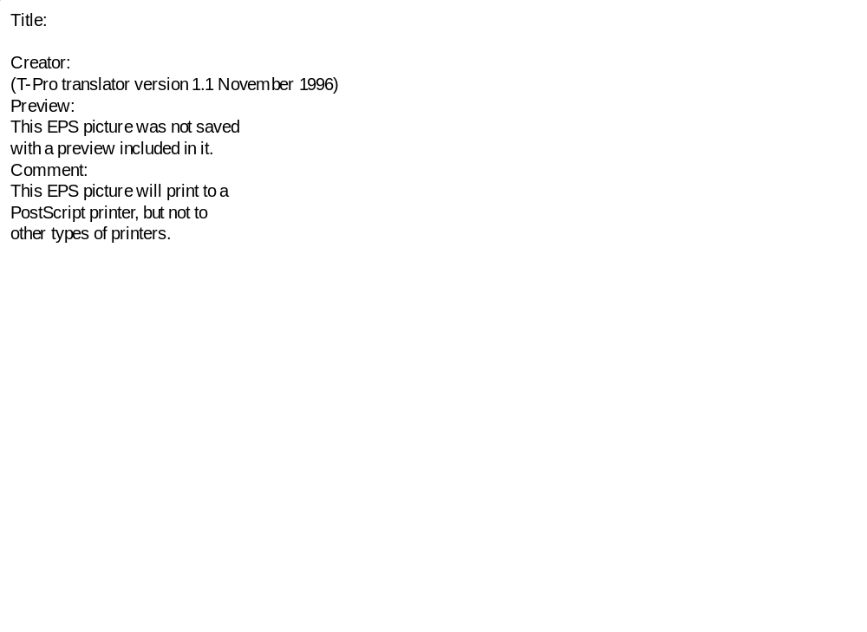

Figure 3
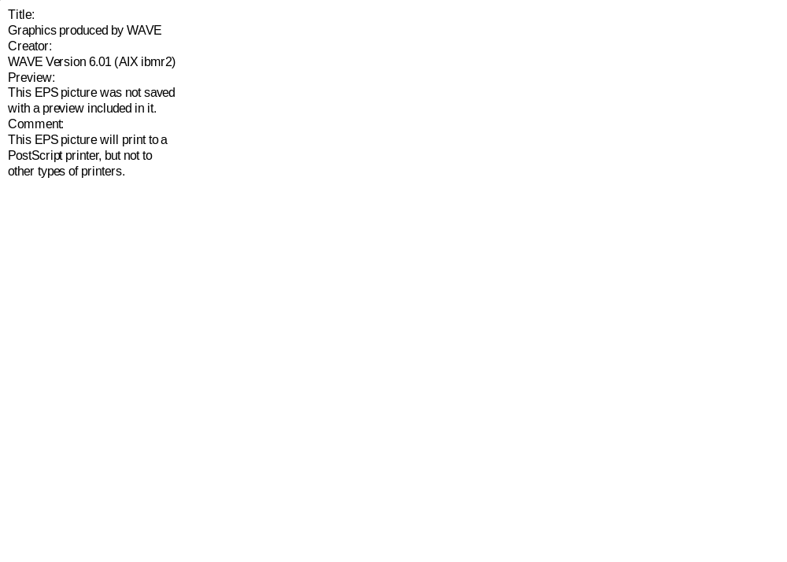
Figure 4
Figure 5

Figure 6

REFERENCES

 This work has been performed as part of the IEA Co-operative Program on the Environmental, Safety and Economic Aspects of Fusion Power. Work at Culham was supported by Euratom and the UK Department of Trade and Industry, that at INEEL by the US Department of Energy, Office of Fusion Energy Sciences, under DOE Idaho Operations Contract DE-AC07-94ID13223.
The shields may not be optimized in all the blanket design concepts. The use of a standard shield and ex-vessel components allowed for more direct comparisons of the influence of each blanket on the level of ex-vessel activation.
As part of our collaboration, these remote handling limits are will be revised in the future to reflect the most recent equipment survivability data in radiation fields and the latest worker radiation protection criteria.
E.T. Cheng, P.Rocco, M.Zucchetti, Y. Seki and T. Tabara, "Waste management aspects of low activation materials", Fusion Technology 34 (1998) 721-727.
J. Raeder, I. Cook, F. H. Morgenstern, E. Salpietro, R. Bünde, E. Ebert, “Safety and Environmental Assessment of Fusion Power (SEAFP): report of the SEAFP project”, EURFUBRU XII-217/95. Brussels: European Commission, 1995.
I. Cook, G. Marbach, L. Di Pace, C. Girard, P. Rocco and N.P. Taylor, "Results, Conclusions, and Implications of the SEAFP-2 Programme", ISFNT-5 invited paper, these proceedings.
Personal communication with Y. Gohar, ANL, March 1999
N.P. Taylor and I. Cook, "Description of Plant Models, Blankets and Structural Materials," UKAEA Culham, SEAFP/2/5.1/UKAEA/1, March 1997
N. P. Taylor and J.- Ch. Sublet, "Description of Additional Plant Models with Silicon Carbide Structure," UKAEA Culham, SEAFP99/S2.1/UKAEA/1, January 1999
C.B.A. Forty and I. Cook, "Low activation structural material candidates for fusion power plants", UKAEA report UKAEA-FUS-365, June 1997.
IAEA "Clearance levels for radionuclides in solid materials: application of exemption principles", interim report for comment, IAEA TECDOC-855, Vienna, January 1996.
W.W. Engle jr., “A Users’ Manual for ANISN, a One-dimensional Discrete Ordinates Transport Code with Anisotropic Scattering”, Oak Ridge Gaseous Diffusion Plant report K-1693, 1967.
A.B. Pashchenko and H. Weinke, "FENDL/E-2.0: Evaluated nuclear data library of neutron-nucleus interaction cross sections and photon production cross sections and photon-atom interaction cross sections for fusion applications, Summary documentation", IAEA-NDS-175, 1998.
R.A. Forrest and J-Ch. Sublet, ‘FISPACT-99: User manual’, UKAEA FUS 407, 1998.
J-Ch. Sublet, J. Kopecky and R.A. Forrest, "The European Activation File: EAF-99 cross section library", UKAEA FUS 408, 1998.
R.A. Forrest, M.G. Sowerby and D.A.J. Endacott, "Activation of structural materials in the outer regions of a fusion reactor", Fusion Technology 1990, Proc. 16th Symposium on Fusion Technology, London, 1990, p.797.
M. Zucchetti, "Impurity Concentration Limits and Activation in Fusion Reactor Structural Materials," Fusion Technology (19), March 1991, pp. 294-303
S. J. Piet, E. T. Cheng, S. Fetter, and J. S. Herring, "Initial Integration of Accident Safety, Waste Management, Recycling, Effluent, and Maintenance Considerations for Low-Activation Materials," Fusion Technology (19), January 1991, pp. 146-161.
E. T. Cheng, "Concentration Limits of Natural Elements in Low Activation Fusion Materials," J. Nuclear Materials 258-263 (1998), p. 1767-1772.

